Gym Membership Enrollment & Front Desk Management
Building Reports, Dashboards, and Custom Pages (UI Builder)
SAHANA R
241401086
1. Aim
To design and build a functional “Gym Membership Enrollment Form” application in Zoho Creator that demonstrates the correct usage of all thirteen Basic Fields available in the Form Builder, while solving the requirement of collecting and managing gym membership details. The project also includes Reports and a UI Builder Dashboard Page to help front-desk staff and trainers view, filter, and monitor membership details from a single screen.

2. Procedure
2.1 Building the Form
A new application, “Gym Membership Enrollment & Front Desk Management,” was created in Zoho Creator. The Membership Enrollment Form was built using thirteen Basic Fields to capture details such as Member Name, Age, Email Address, Contact Number, Residential Address, Emergency Contact Name, Membership Type, Membership Plan, Preferred Activities, Fitness Goals/Medical Notes, Preferred Start Date, Preferred Workout Slot, and Health Declaration/Waiver. LC-02-Gym Membership LC-02-Gym Membership

2.2 Building the Reports
- Open Reports in the left sidebar. Zoho Creator automatically generates a report from the form. Rename it “All Membership Enrollments” and display the important member details such as Member Name, Age, Contact Number, Membership Type, Membership Plan, and Preferred Activities.
- Create a second report and group it by the Membership Plan field. Name it “Membership Plan Report” so that members can be organized based on their selected plans.
- Create a third report named “Gym Member Summary” that displays important member and fitness information in a single table for the front-desk staff and trainers to review easily.

2.3 Building the Dashboard Page (UI Builder)
- Go to Pages in UI Builder → click New Page → choose Blank Page → name it “Dashboard.”
- Add three summary panels to display important information such as Total Gym Members, New Members, and Upcoming Memberships.
- Add a Membership Plan component to display membership information and allow the user to view different membership plan categories.
- Add a Column Chart using the Membership_Plan field to display the number of members under each membership plan. The Membership Plan is defined as a Drop Down field in your project. LC-02-Gym Membership
- Add an “All Membership Enrollments” button/link so that the complete membership report can be opened directly from the dashboard.
- Arrange the dashboard as:
Total Members / New Members / Upcoming Memberships → Membership Plan → Column Chart → All Membership Enrollments
- Preview the dashboard and check that the panels, chart, and report links display the correct information.
- Check Form, Report, and Page permissions under Settings to ensure the required users have appropriate View/Add access.
- Publish the Dashboard page and, if required, set Dashboard as the default landing page of the application.

3. Output
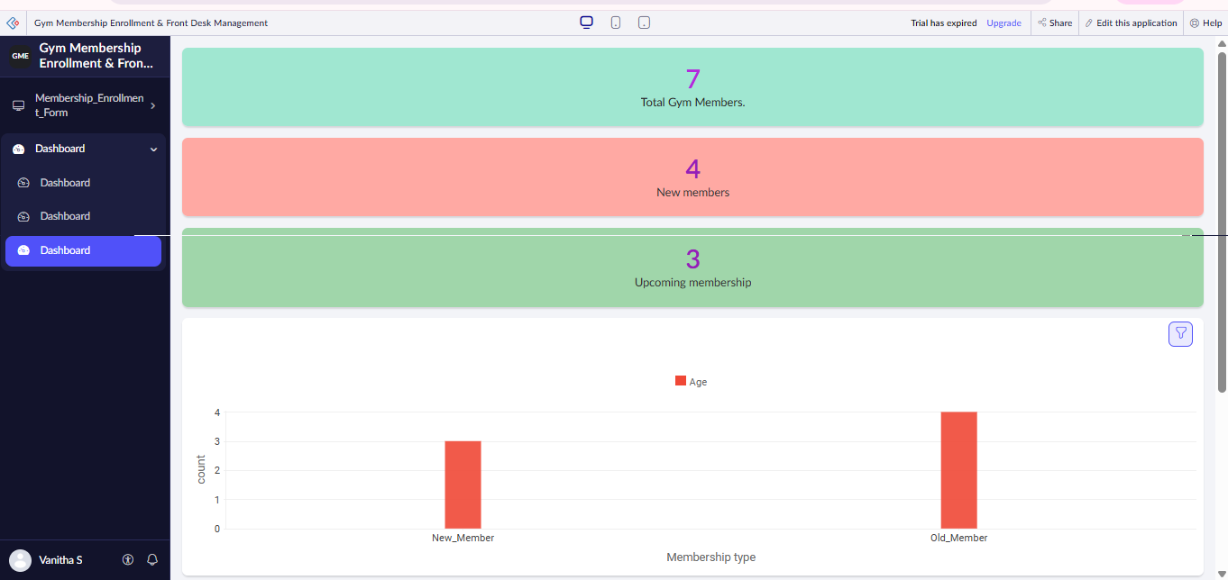

The Dashboard displays total gym members, new members, upcoming memberships, and a column chart based on membership type.

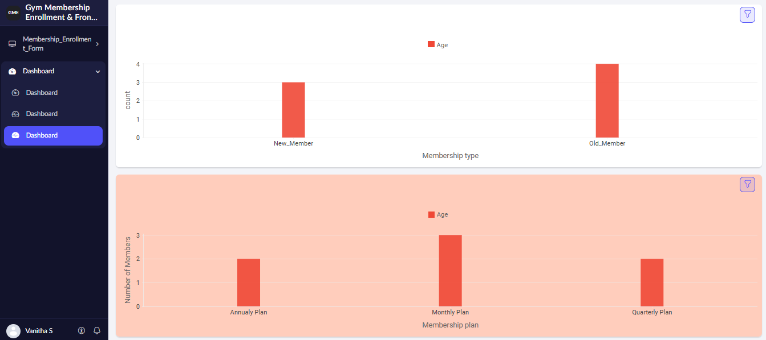

The Dashboard displays total gym members, new members, upcoming memberships, and a column chart based on membership type.

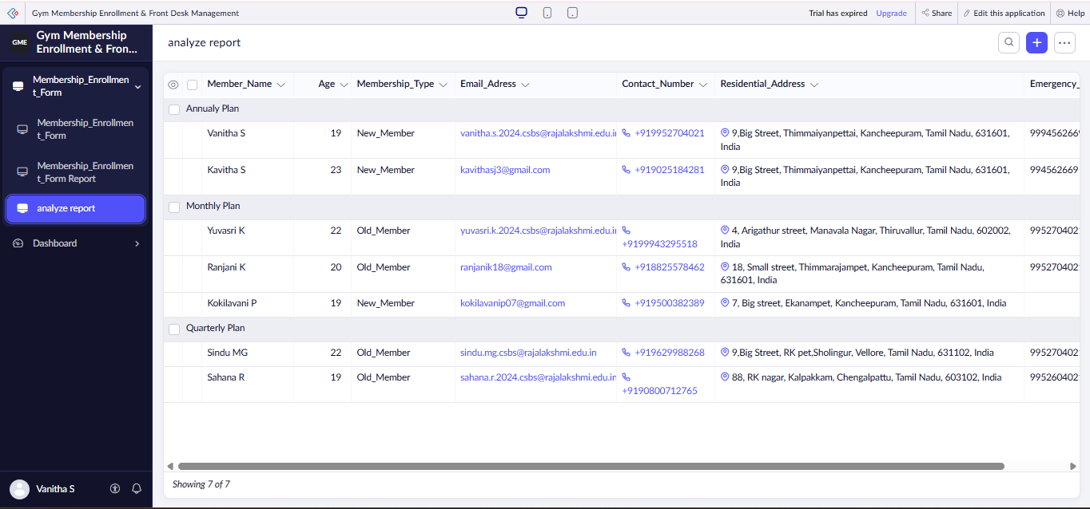
The Analyze Report organizes member details according to membership plans such as Annual, Monthly, and Quarterly Plans.

Result
Thus, the Gym Membership Enrollment & Front Desk Management application was successfully created using Zoho Creator. The application includes the Membership Enrollment Form, Reports, and Dashboard Page with summary panels, a membership plan chart, and report access. It helps the gym staff to easily view, manage, and track member enrollment details.

